Ideation Phase
Define the Problem Statements

Date | 31 January 2026
Team ID | LTVIP2026TMIDS87433
Project Name | Rain Prediction Pipeline Flask
Maximum Marks | 2 Marks

Customer Problem Statement:
This section helps us understand the user’s point of view and the real challenges they face related to rainfall prediction. By identifying their needs and difficulties, we aim to design a solution that is practical and easy to use.
A clear problem statement helps our team build a system that predicts rainfall accurately and supports users such as farmers, travelers, and event planners in making better decisions. It also allows us to empathize with users and understand how they experience weather uncertainty in daily life.
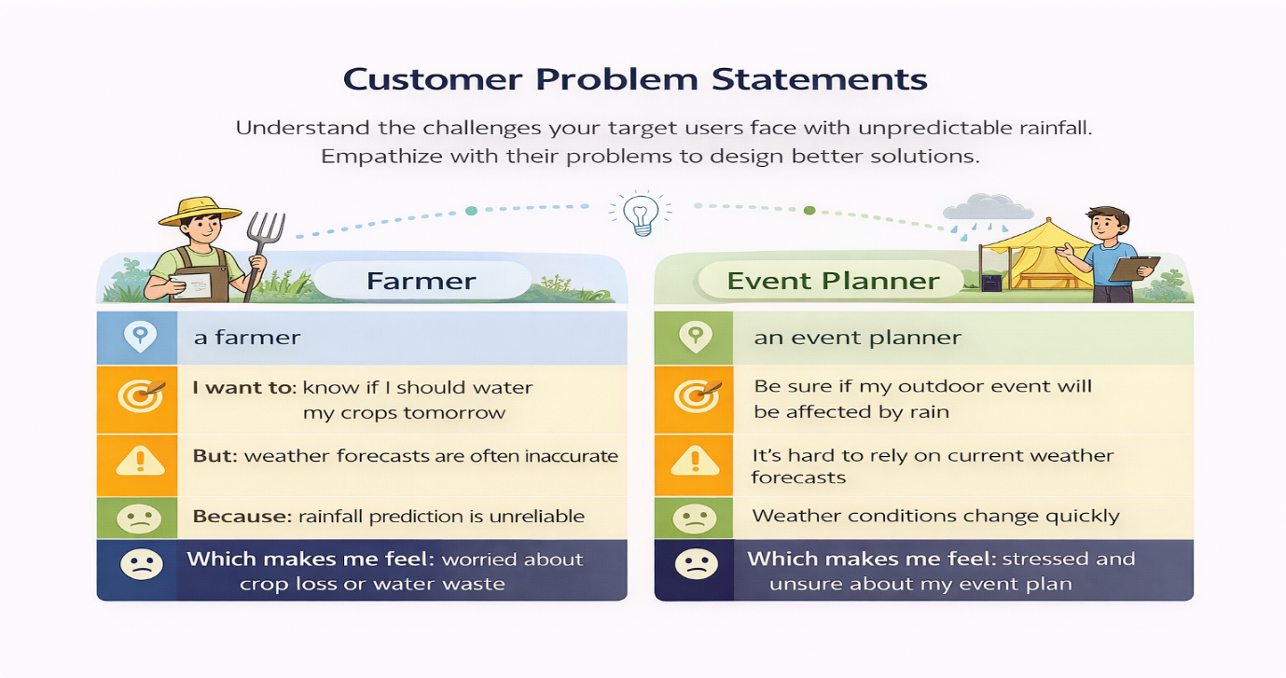

Example: 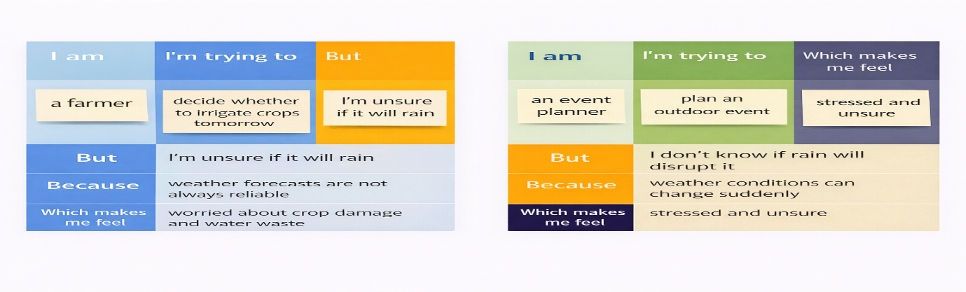

Problem Statement (PS) | I am (Customer) | I’m trying to | But | Because | Which makes me feel
PS-1 | A Farmer | predict whether it will rain so I can plan my activities | I don’t have an easy-to-use and accurate prediction tool | weather apps are often generic and not data-driven for my local inputs | uncertain and stressed about making wrong decisions
PS-2 | Beginner data analyst | understand rainfall trends and predictions | I struggle to connect machine learning results with a simple interface | most ML projects don’t provide real-time web visualization | confused and disconnected from the model outputs

